# All Visualizations and Troubleshooting

Note: could not import into Quip because the file type was not supported.

## Making New Visualizations in a Dashboard

1. Ask a question in the Q bar
2. use the meatball icon to export to CSV
3. make a new analysis with the CSV
4. add it to the dashboard

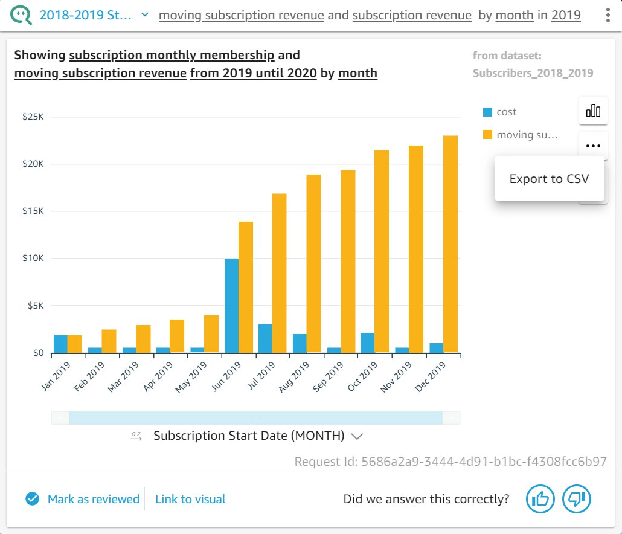

## Q Visualizations (the only details are the axis for the visualizations)

### Q Dashboard History

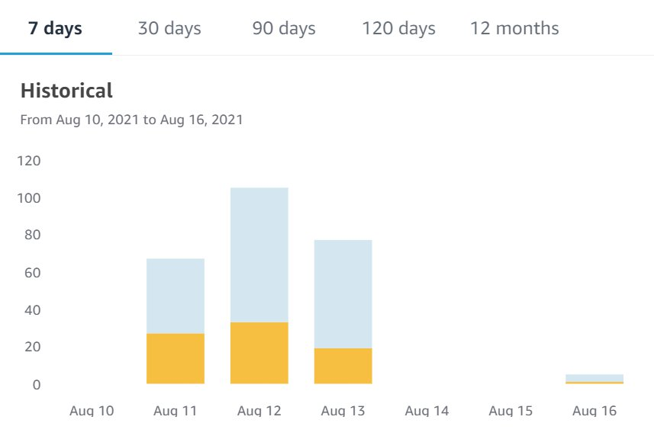

### Platform Traffic - GRAPH ONLY

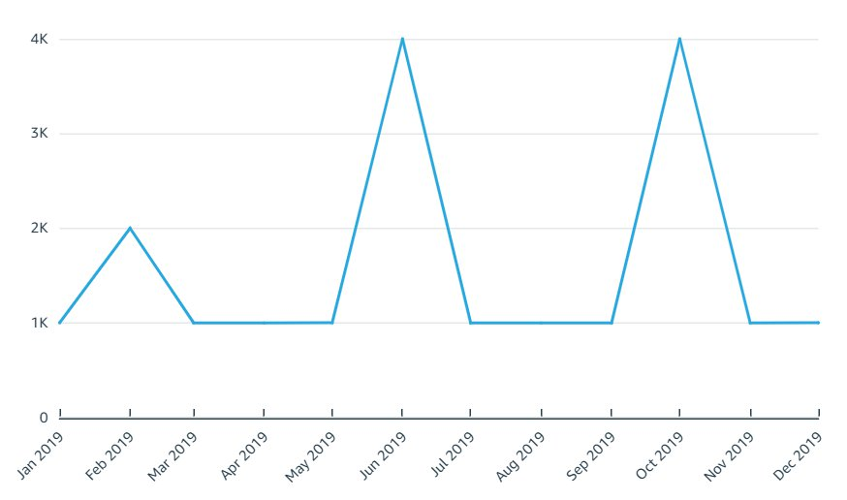

### Moving vs monthly subscription revenue - BAR GRAPH ONLY

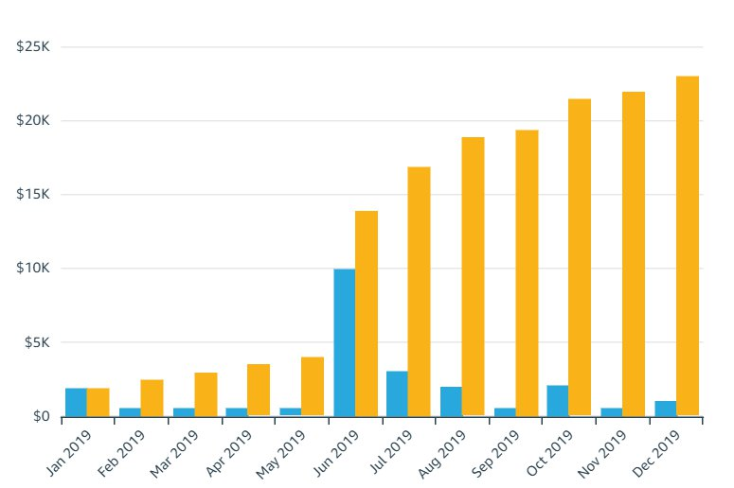

## Q Bar Visualizations

### [1]  q bar actions - which streaming platform was the most popular in 2019

**Alt Text:**

QuickSight Q bar with dashboard in the background. Reader is searching “Which streaming platform was the most popular in 2019?” in the Q bar. QuickSight Q is asking “Need to make a change?” and prompts the following options: “Type your search” in the search bar below, “Add a filter” which goes to new browser tab , “Add a calculated field” which goes to a new browser tab, “Skip this term”, and “Learn more”.

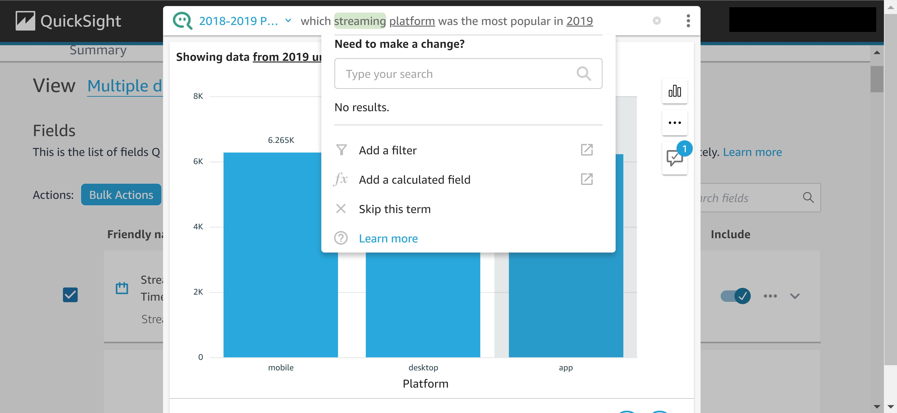

### [2] Q unable to answer a question

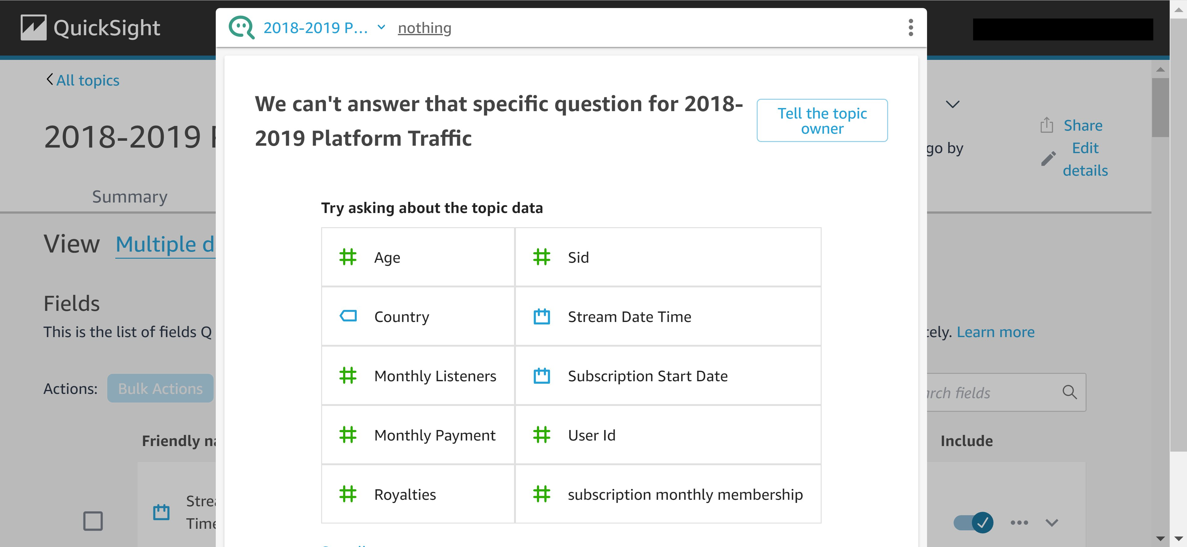

### [3] question -which streaming platform was the most popular in 2019

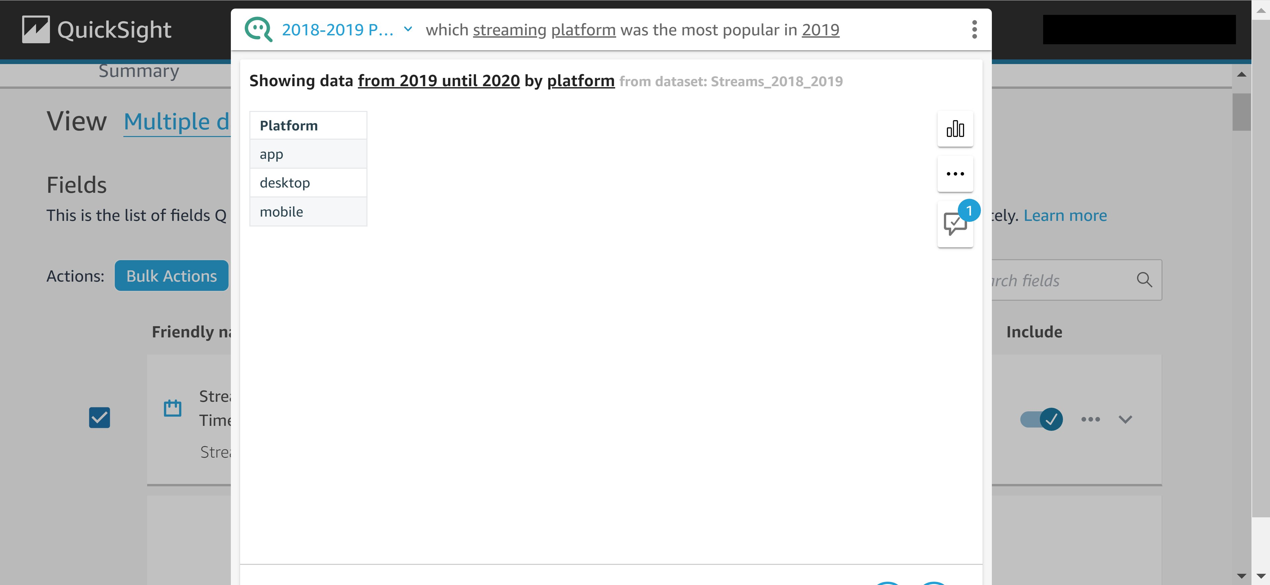

### [4] visualization - which streaming platform was the most popular in 2019

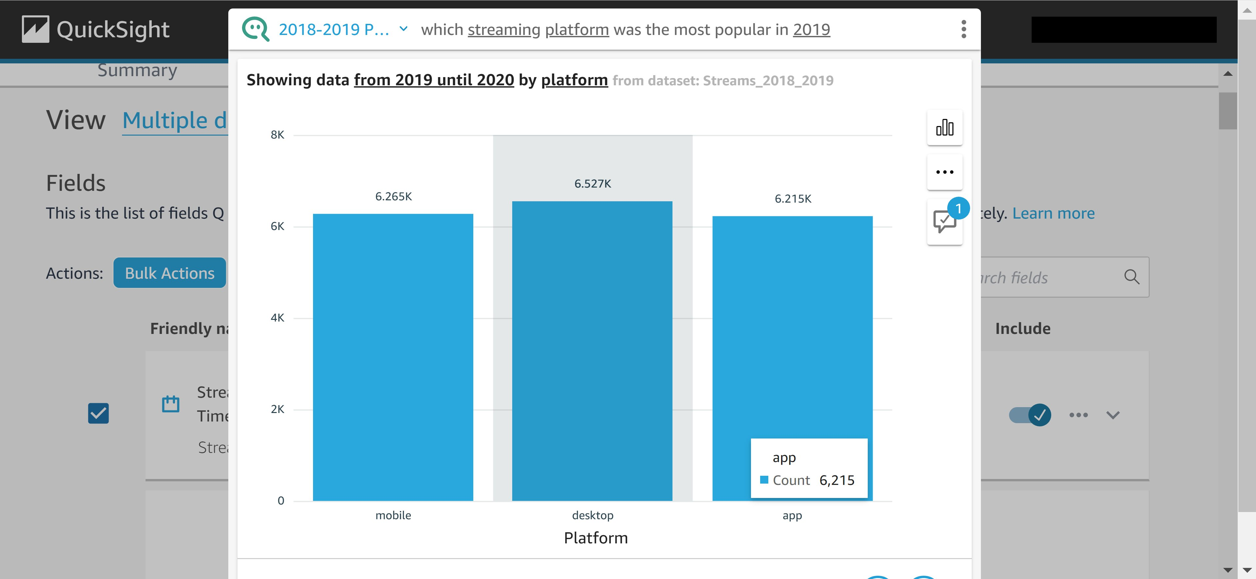

### [5] platform access by month in 2019

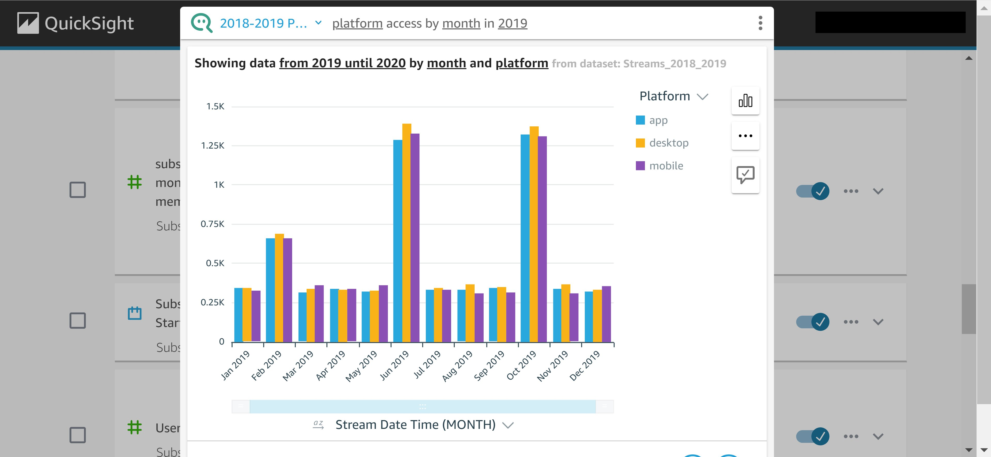

### [6] subscription revenue in 2019 by month

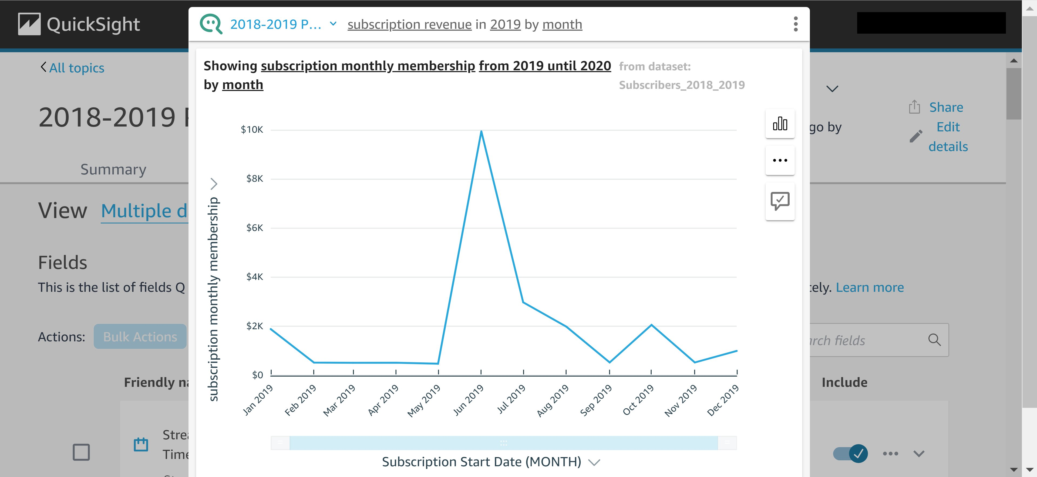

### [7] top 10 artist by song listens

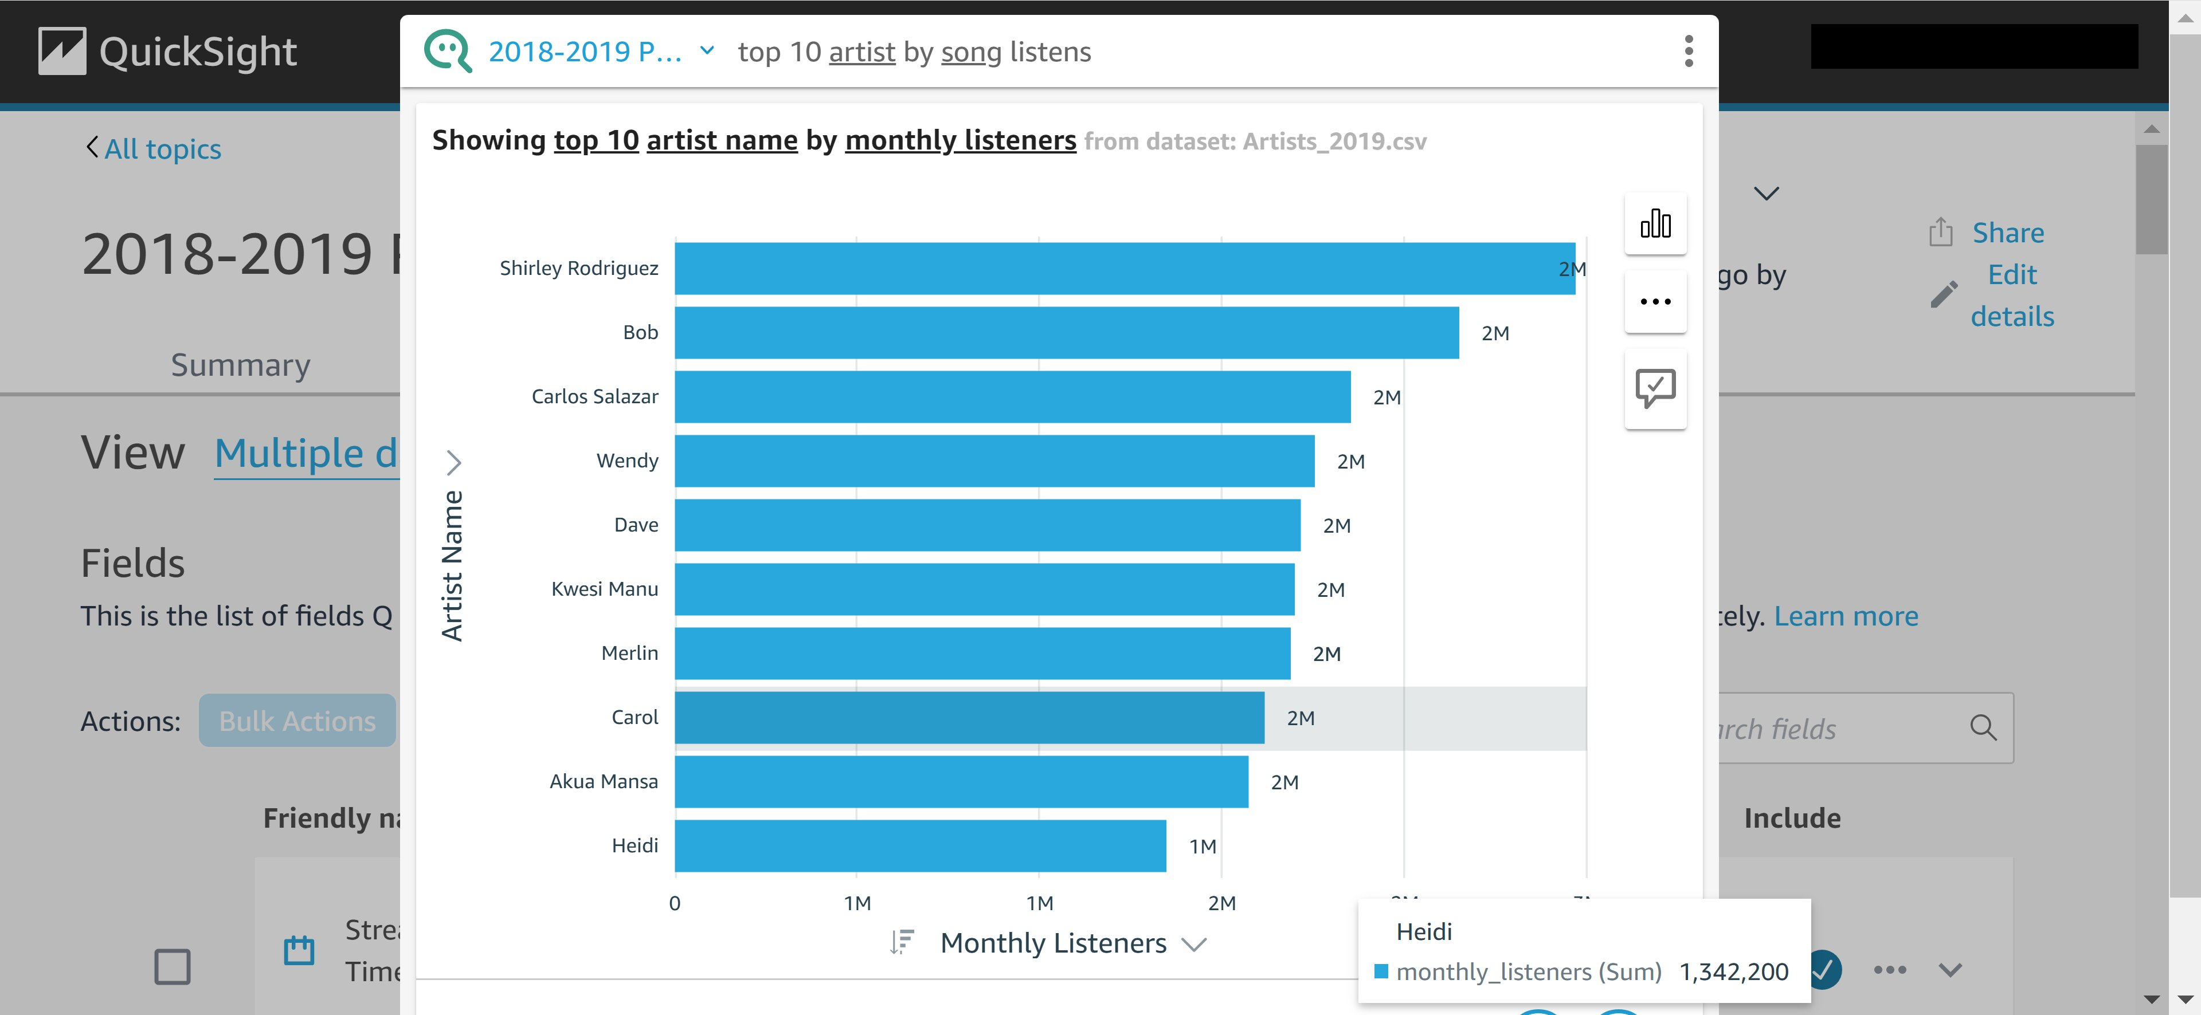

### [8] moving subscription revenue vs subscription revenue (monthly)

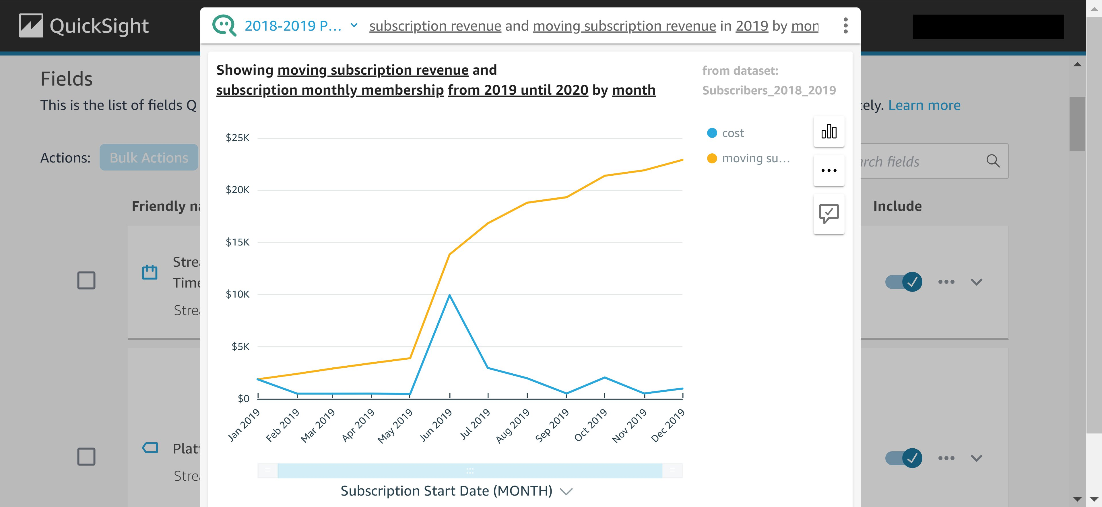

### [9] moving subscription revenue by month

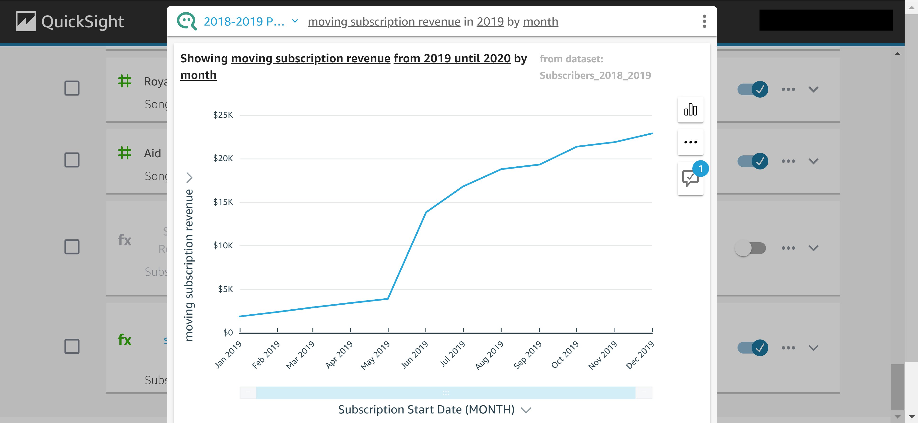

### [10] how many users join by month in 2019

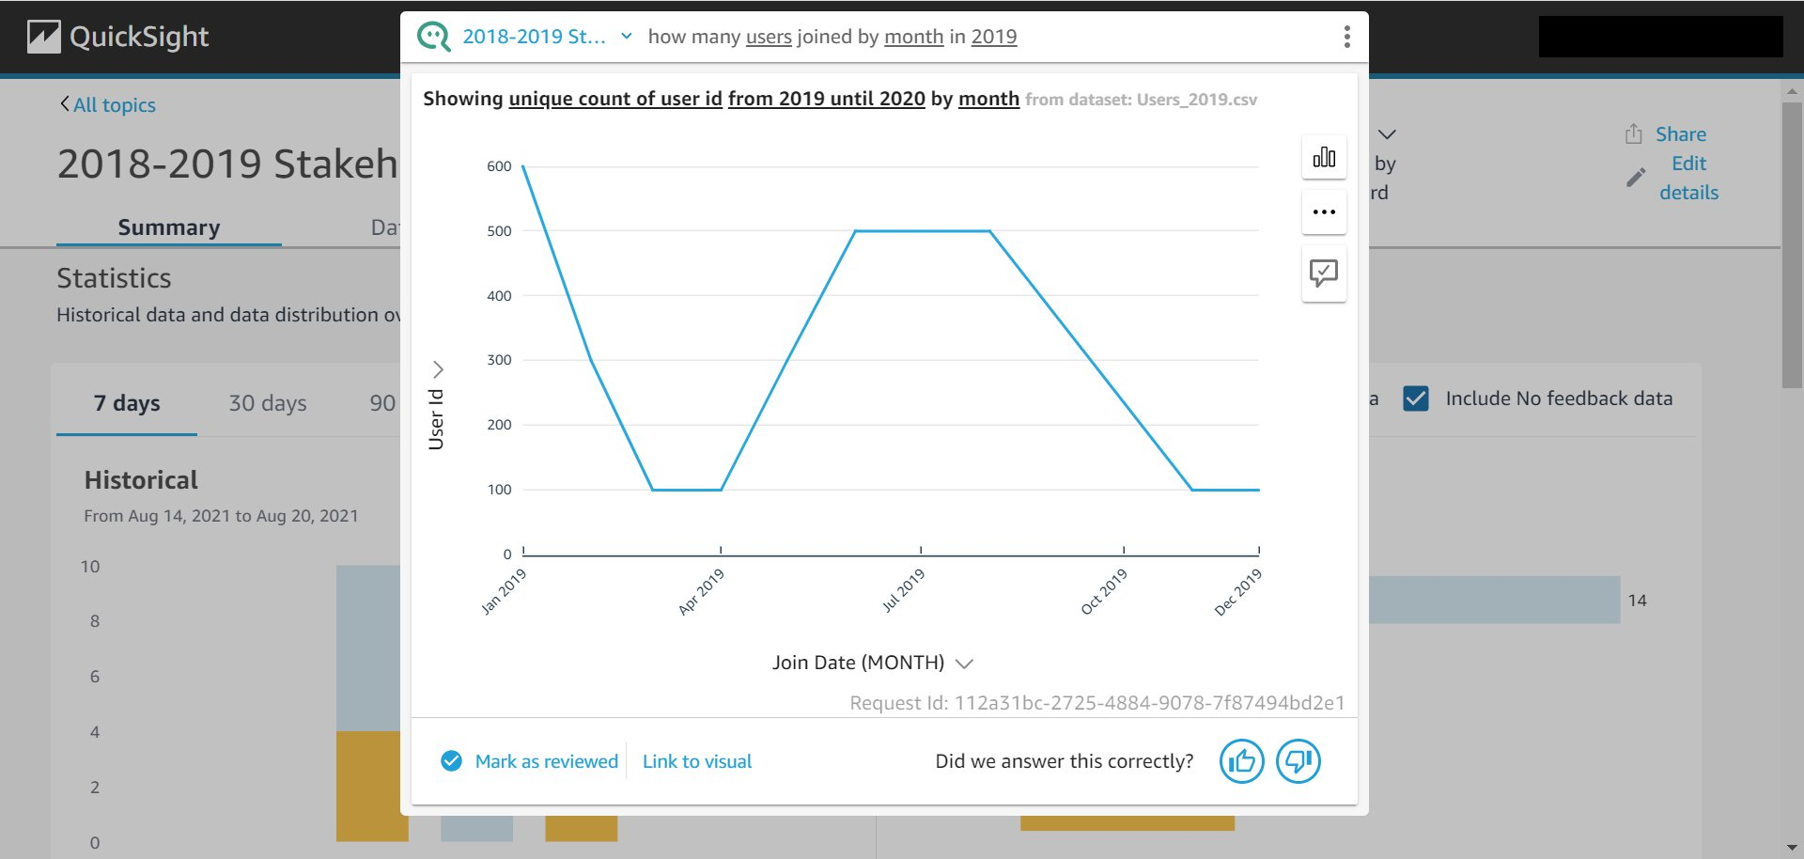

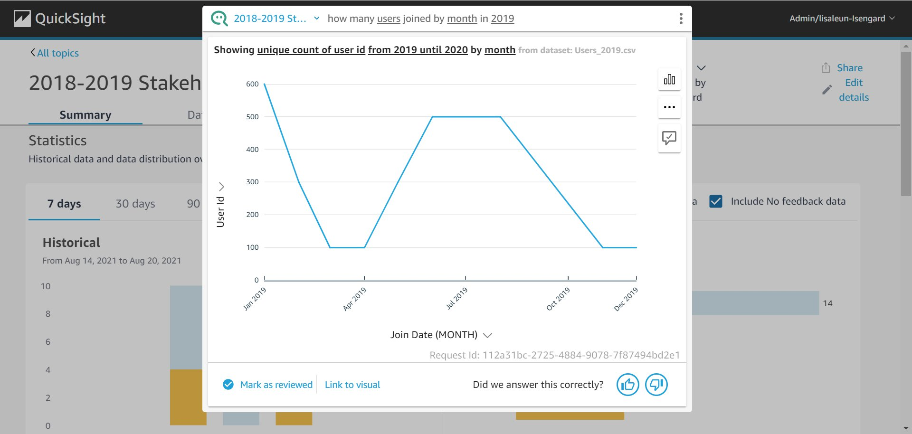

### [11] show me platform traffic by month in 2019

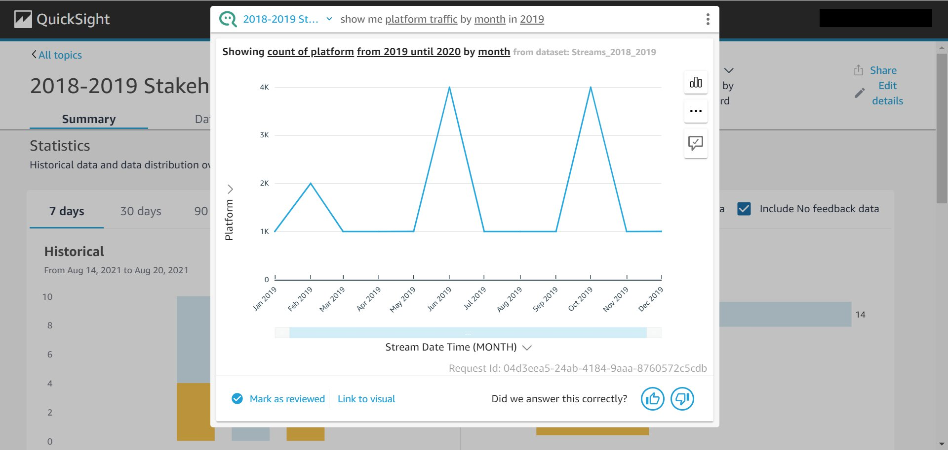

## PROBLEM - finding the top artist correct graph (in screenshots)

### INCORRECT FIRST ANSWER - who was the top artist in 2019

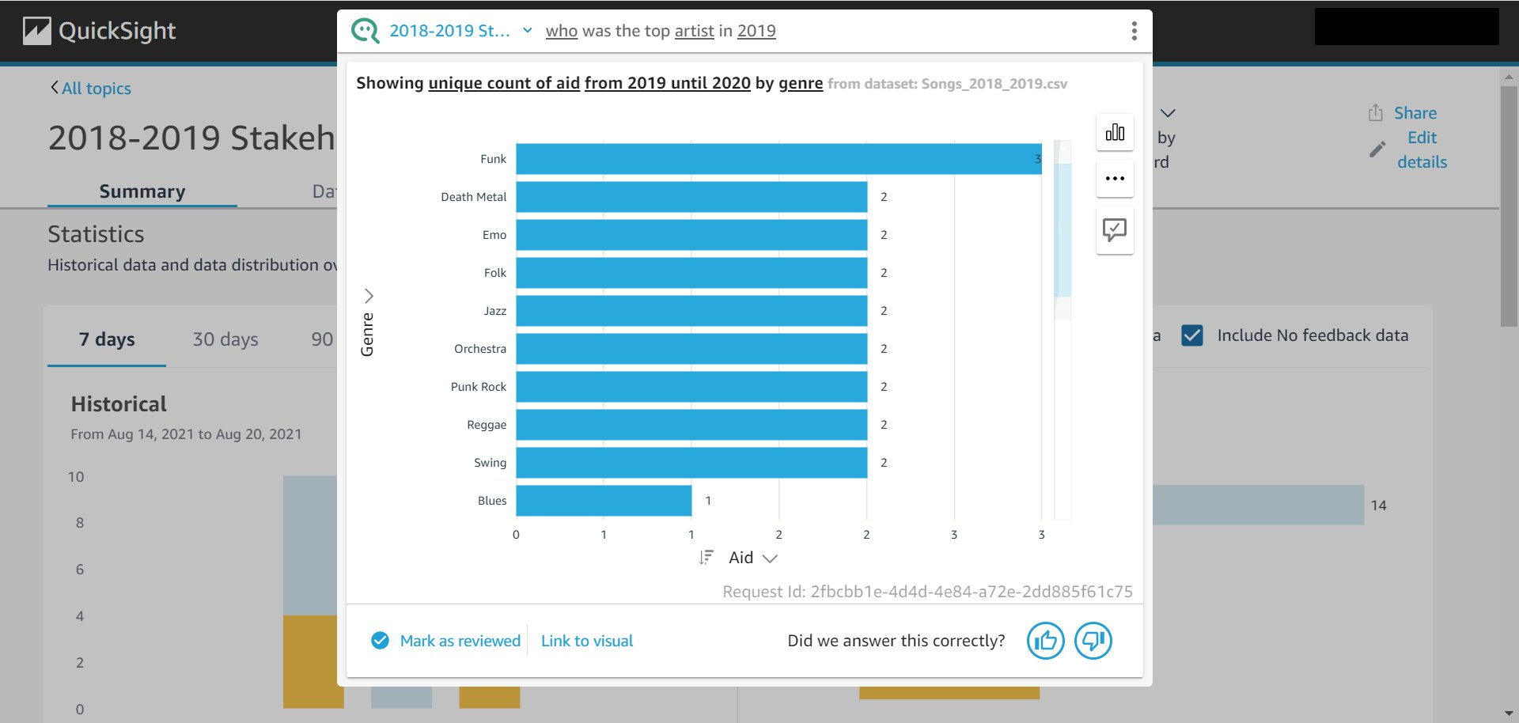

### ATTEMPTED FIX - who was the top artist in 2019 → top 10 artists by monthly listeners in 2019

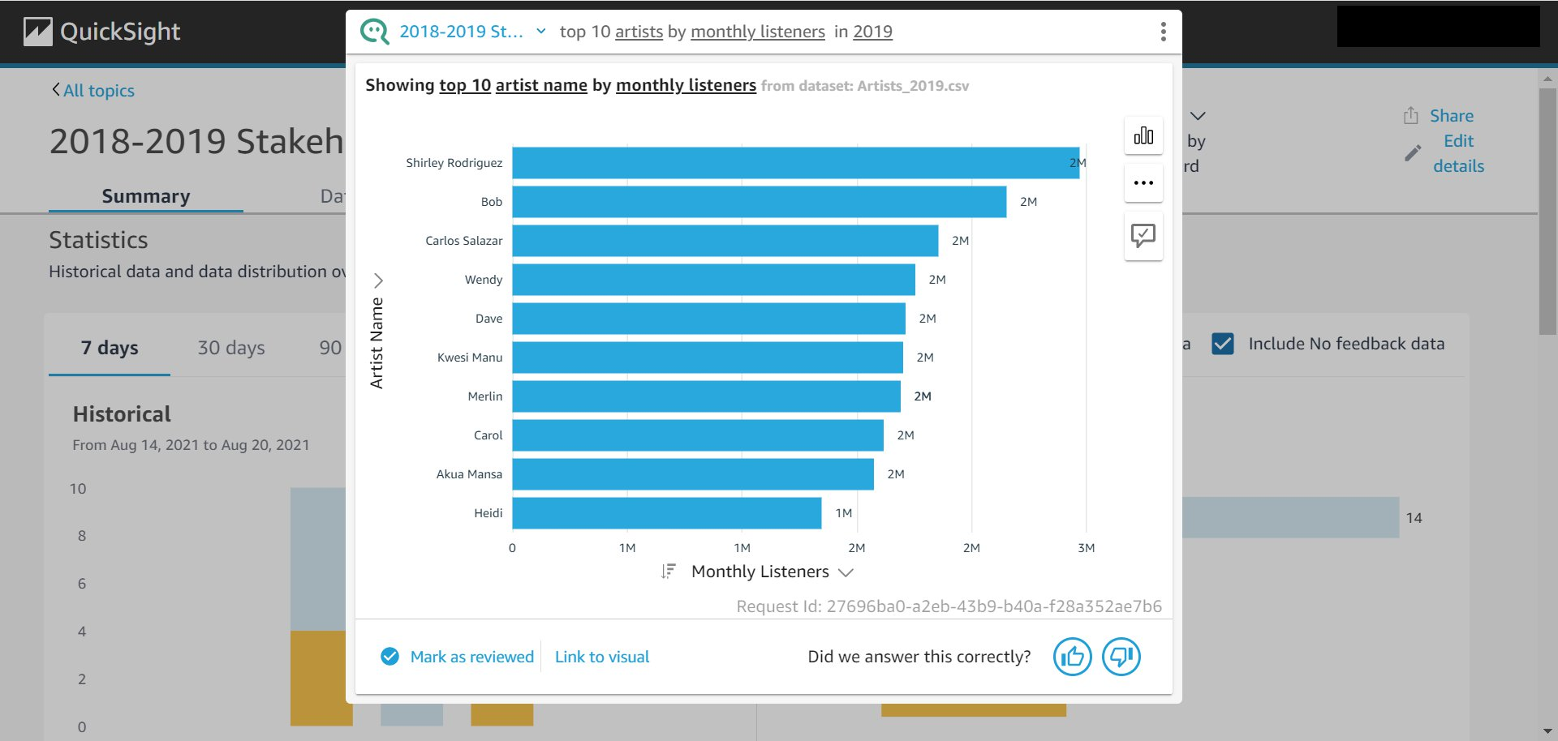

### VISUALIZATION ZOOM OUT - top artist by monthly listeners in 2019

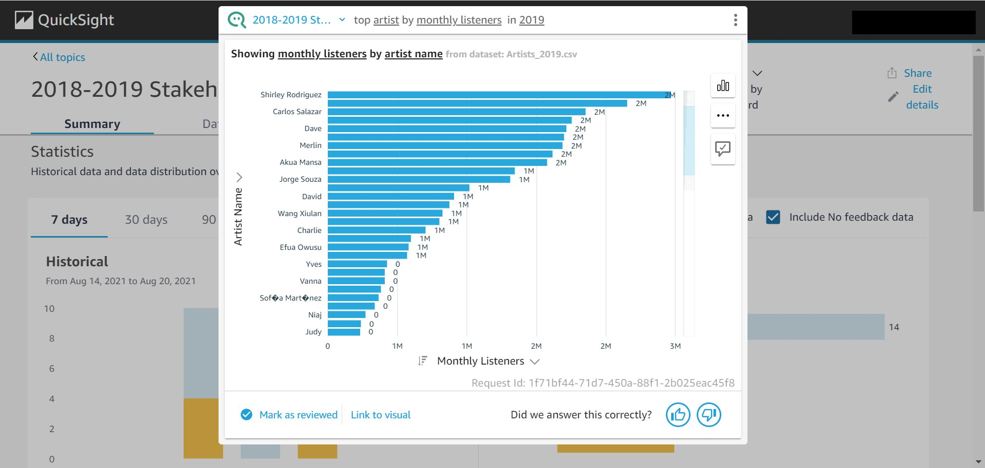

### VISUALIZATION ZOOM IN -top artist by monthly listeners in 2019

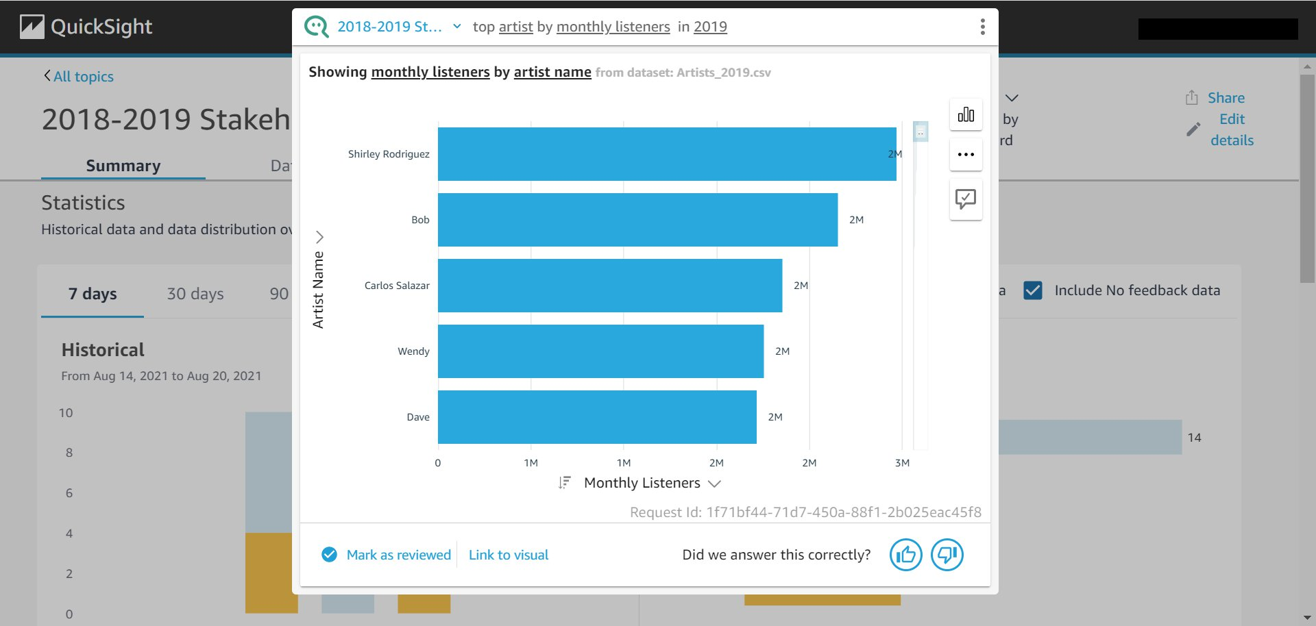

### STILL INCORRECT - provides top 10 artists for who was the top artist in 2019 by monthly listeners

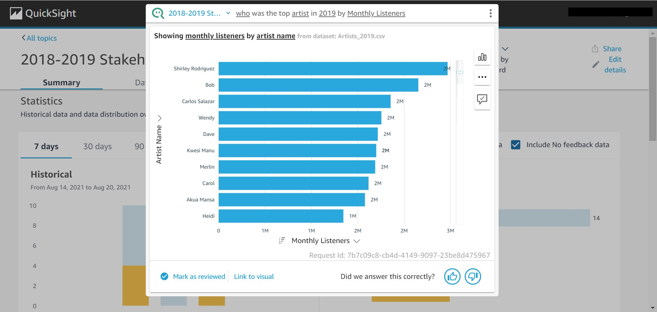

## PROBLEM - when do people listen to music; troubleshooting with Q

### INCORRECT - when do people listen to music (1st Q attempt)

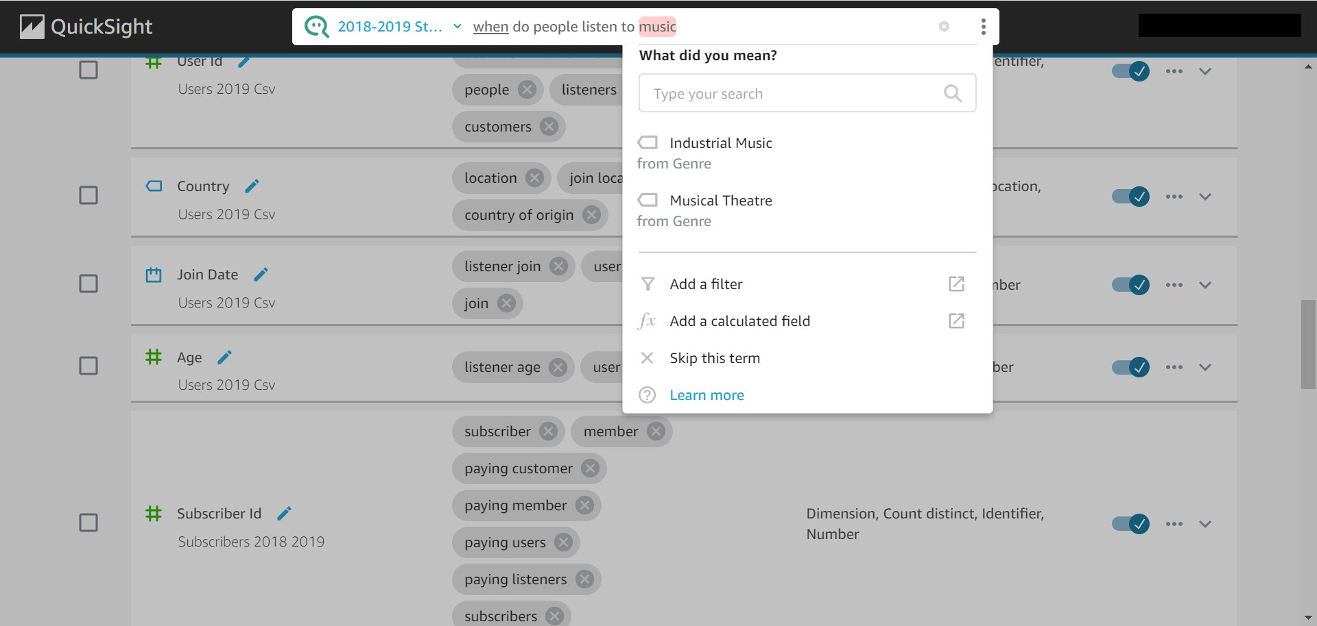

### table - when do people listen to music (after skipping the term “music”) (Q-selected)

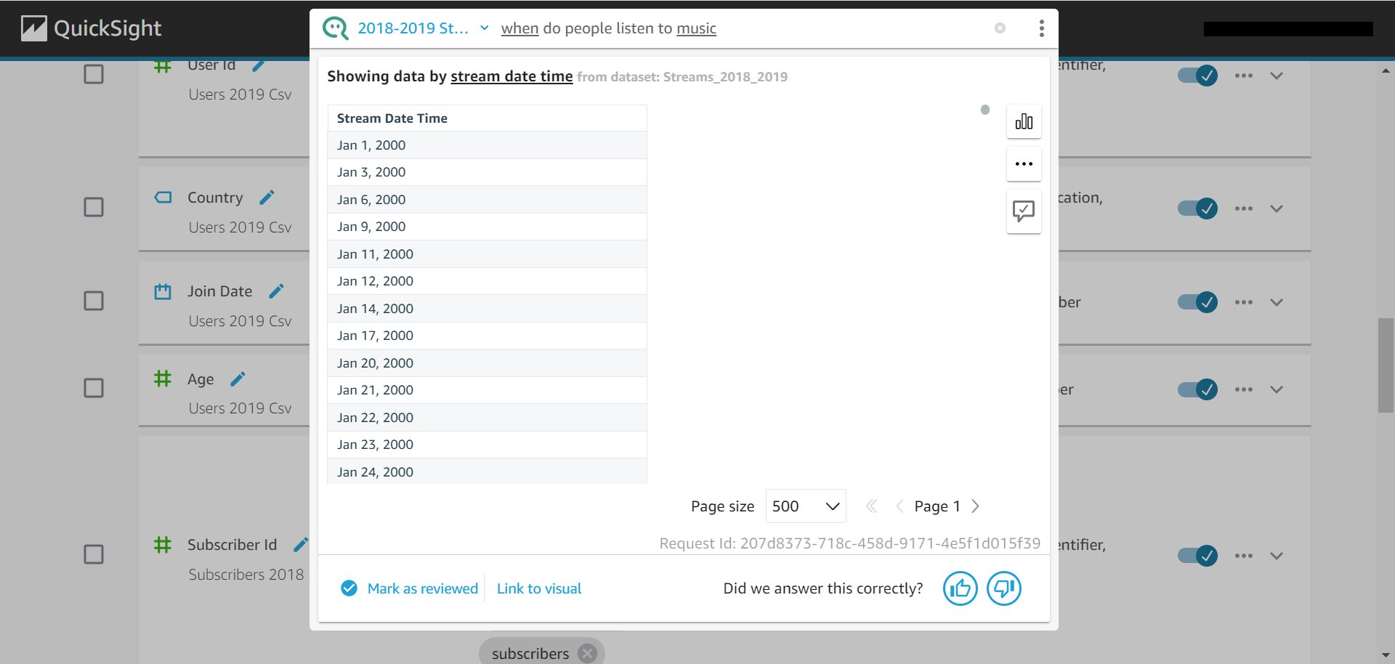

### graph - when do people listen to music (after skipping the term “music”) (user selected)

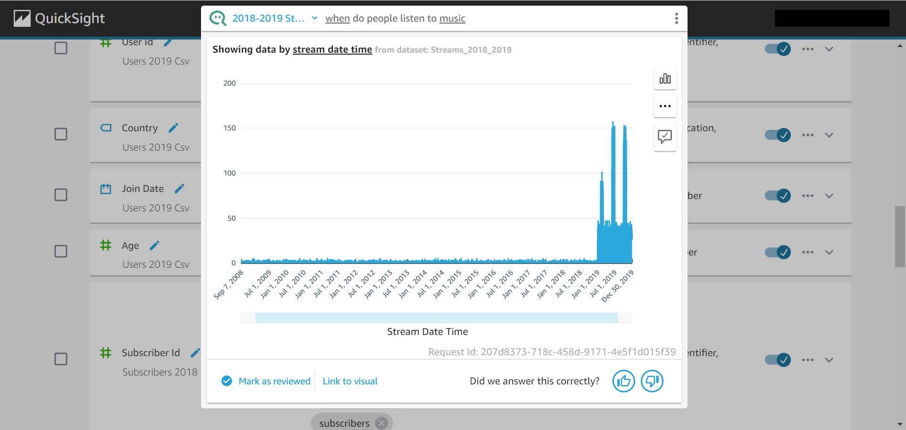

### ADDING TIME  - when to people listen to music in 2019 table (Q-selected)

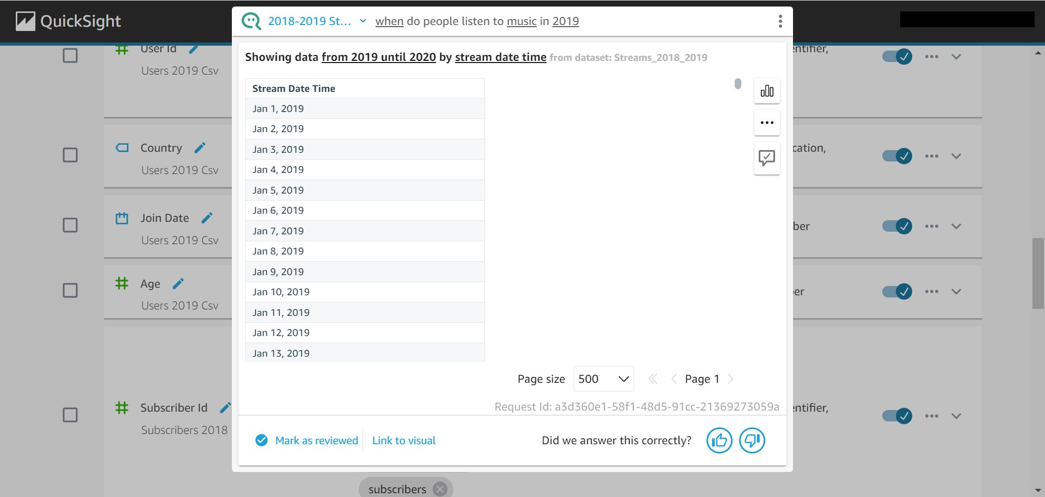

### ADDING TIME  - when to people listen to music in 2019 graph (user-selected)

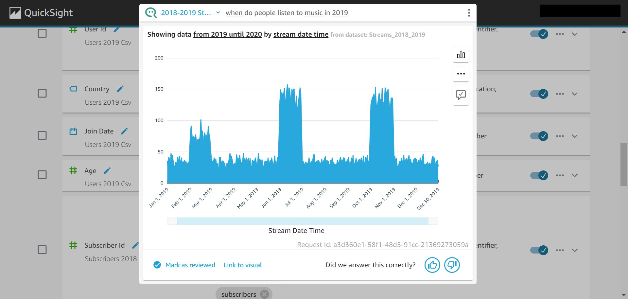

## PROBLEM - most popular stream time/when do people stream the most (and how many?); anticipated the most popular stream date/time by the number of streams at that given point in time (calculated field may have been better)

### Initial Question (Q-selected vis) → pulled up all stream date/times

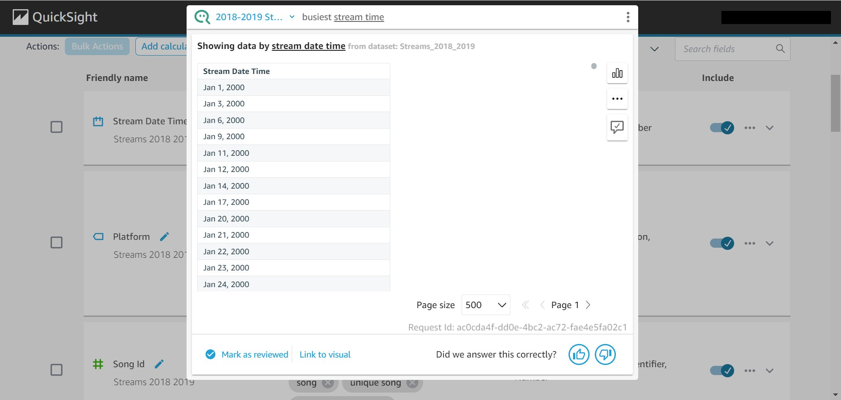

### 2nd Attempt changed wording (Q-selected vis) → incorrectly pulled data for subscription start date?

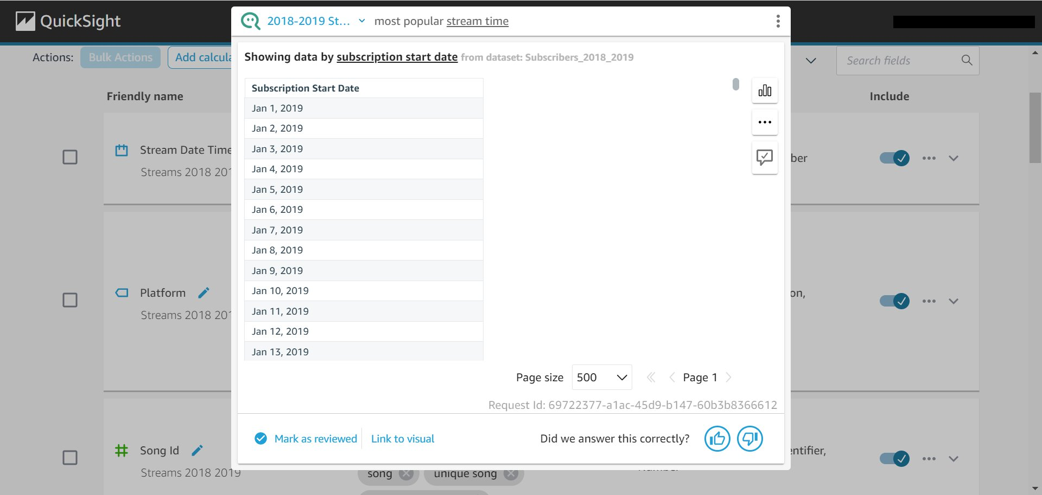

### 3rd attempt  added  condition to filter by (Q-selected vis) → created how many platforms there were? not quite right because streams are in the 1000s...

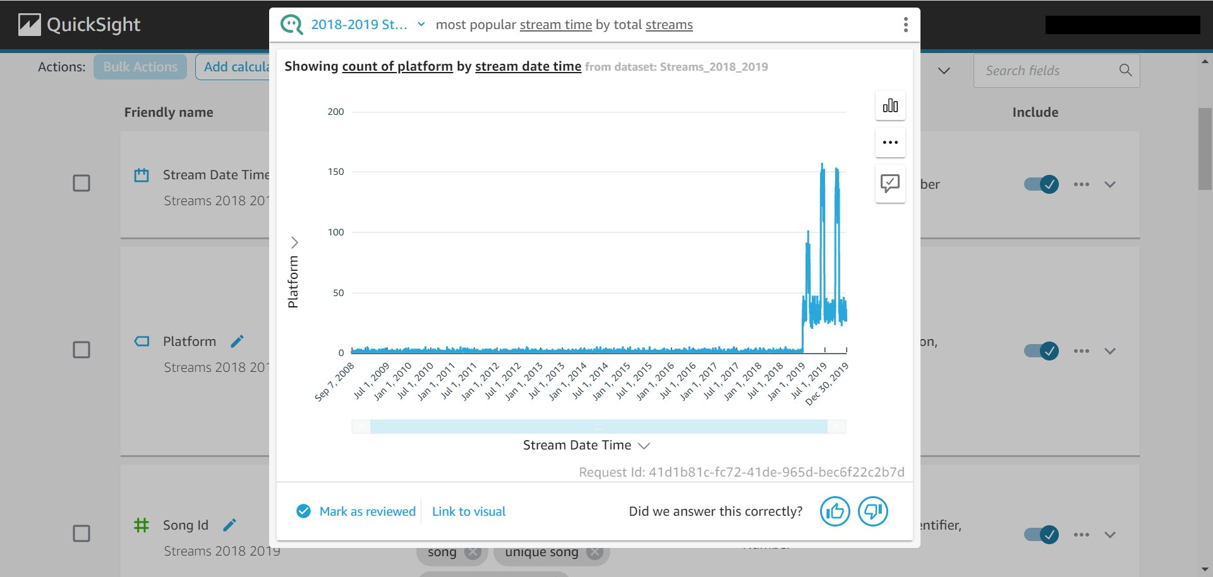

### 4th attempt by adding  a time period (2019) → still using platform as an axis

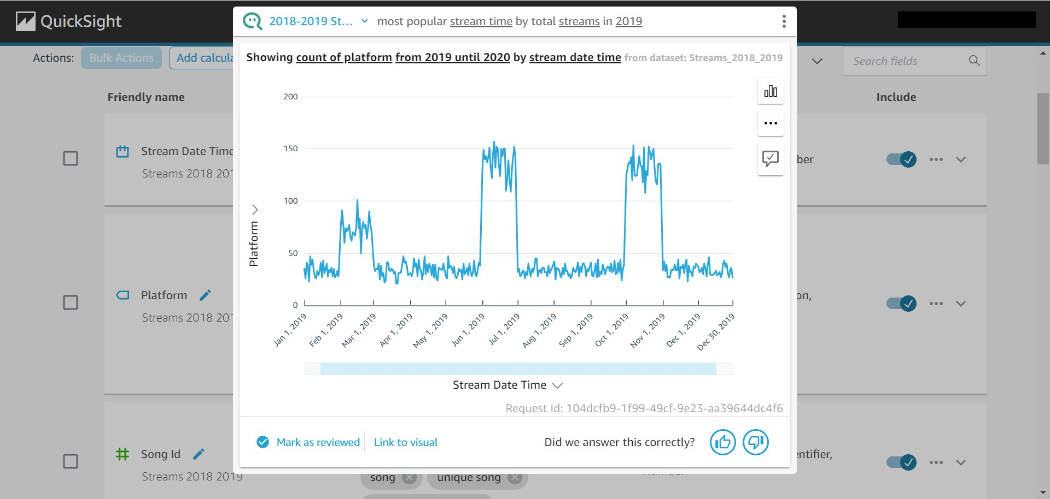

### 5th attempt - disambiguating term options (need to make a change?)

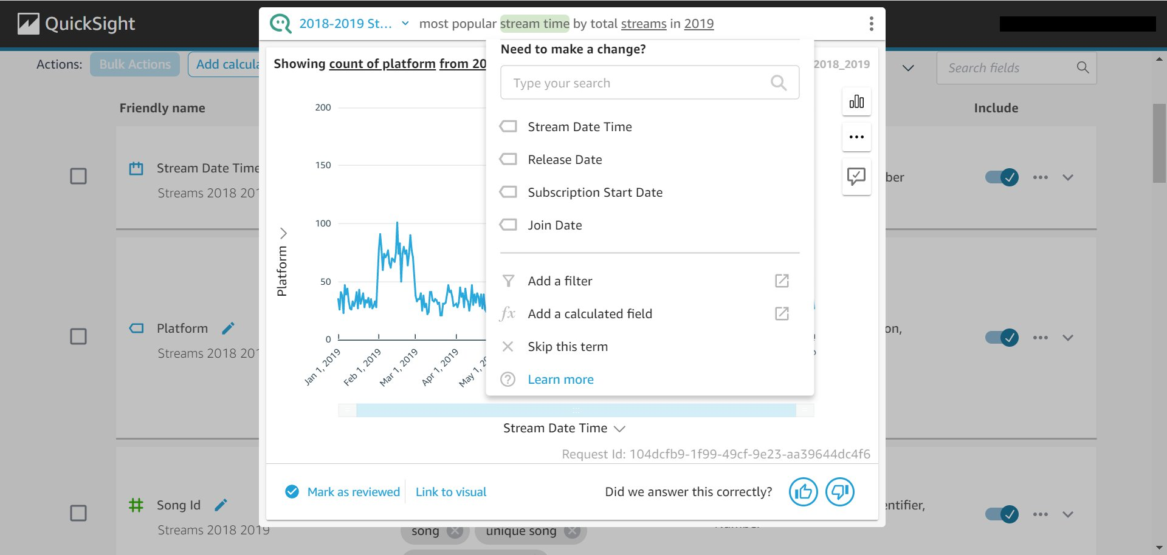

### 5th attempt - disambiguating term options (switch axis)

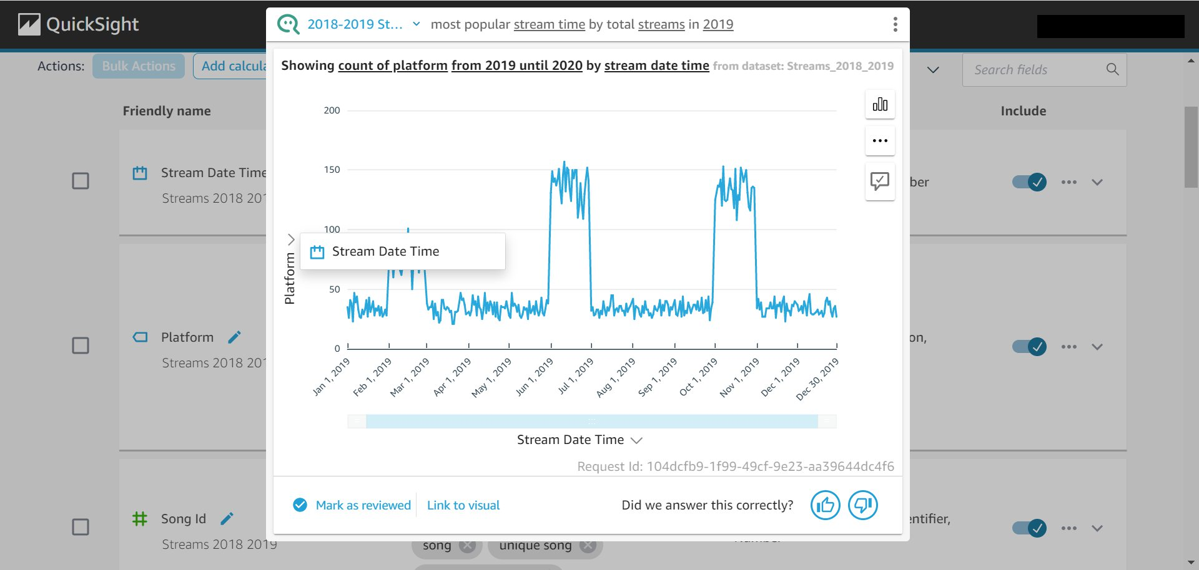

### 6th attempt tried to disambiguate but it didn’t give me what i was looking for

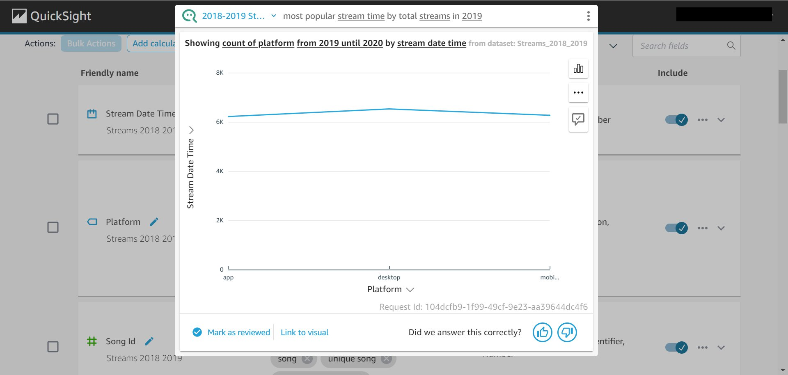

### 7th attempt back to before

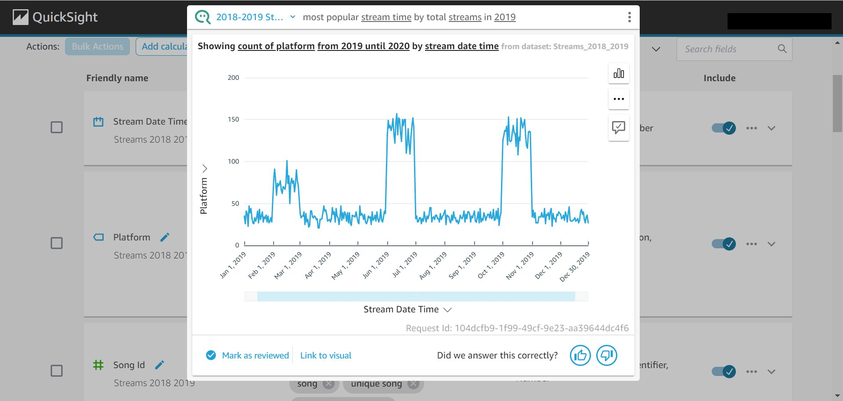

### f